Name : SK.Kashifa

Registration no :192121135

Home Loan Management system

Class diagram :

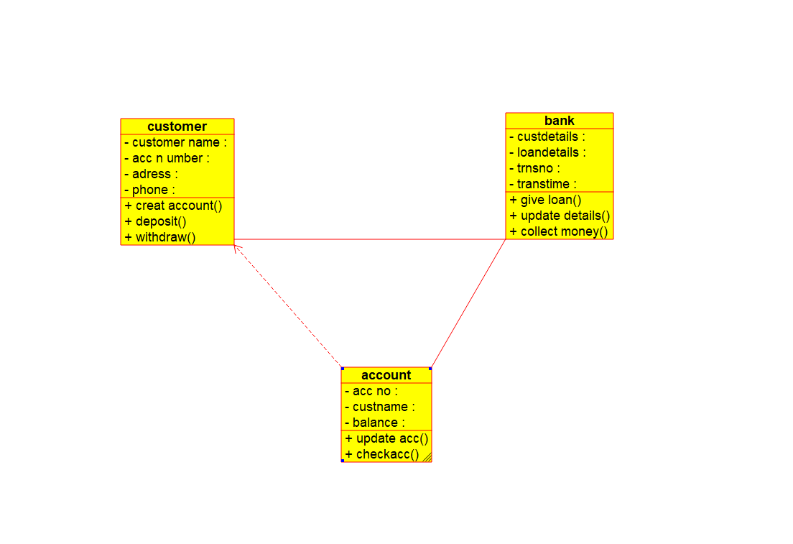

Activity diagram :

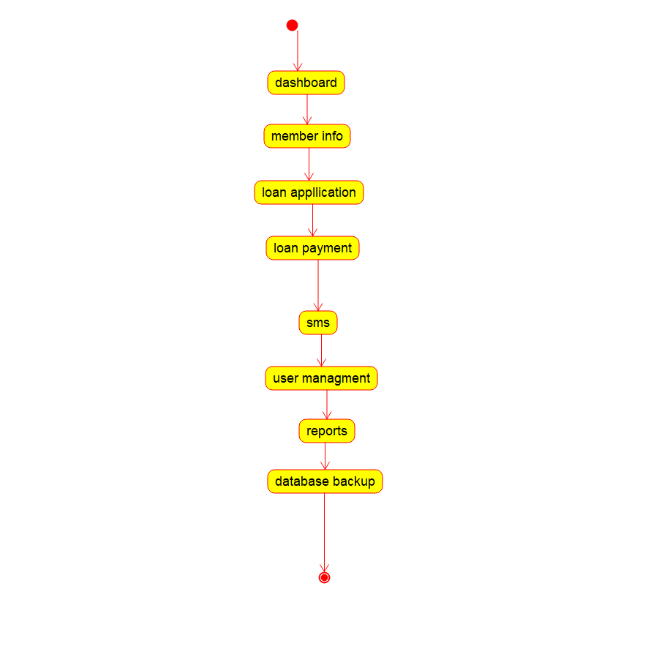

Usecase diagram :

